Matteo Falasconi (2268546)

Guy Beaulieu

Math for Computer Science

December 12th, 2022

**Hand In #4 (Exit Assessment)**

Starting coordinates: (9, 18)

Ending coordinates: (14, 22)

**1. DDA Algorithm**

Step 1: Step 1. Calculate Δx, Δy and M from the given input.

* Δx = 14 - 9 = 5
* Δy = 22 - 18 = 4
* M = 4 / 5 = 0.8

Step 2. Find a number of steps or points in between the starting and ending coordinates.

Since |Δx| > |Δy| = 5 > 4

Steps = |Δx| = 5

Step 3.

Since M = 0.8 (Case 1)

x_p + 1 = 1 + x_p

y_p + 1 = M + y_p

|  |  |  |  |
| --- | --- | --- | --- |
| **n** | **x_n** | **y_n** | **geo** |
| 0 | 9 | 18 | (9, 18) |
| 1 | 10 | 18.8 | (10, 19) |
| 2 | 11 | 19.6 | (11, 20) |
| 3 | 12 | 20.4 | (12, 20) |
| 4 | 13 | 21.2 | (13, 21) |
| 5 | 14 | 22 | (14, 22) (STOP) |

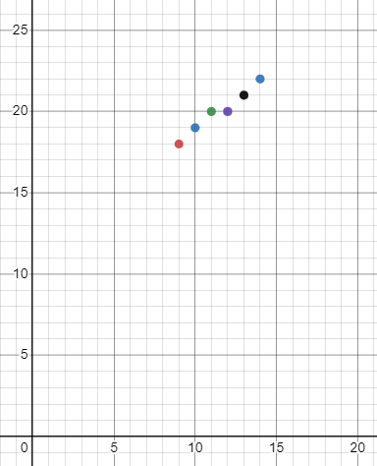

**2. Simple Bresenham Line Drawing Algorithm**

Step 1. Calculate Δx and Δy from the given input.

* Δx = 14 - 9 = 5
* Δy = 22 - 18 = 4

Step 2. Calculate the decision parameters P_k.

P_0 = 2(4) - 5 = 3

Step 3.

**1st Iteration (P_0 >= 0):** 3 + 2(4) - 2 = 1 = P_1

X_1 = 9 + 1 = 10

Y_1 = 18 + 1 = 19

**2nd Iteration (P_1 >= 0):** 1 + 2(4) - 2 = -1 = P_2

X_2 = 10 + 1 = 11

Y_2 = 19 + 1 = 20

**3rd Iteration (P_2 < 0):** -1 + 2(4) = 7 = p_3

X_3 = 11 + 1 = 12

Y_3 = 20 = 20

**4th Iteration (P_3 >= 0):** 7 + 2(4) - 2(5) = 5 = P_4

X_4 = 12 + 1 = 13

Y_4 = 20 + 1 = 21

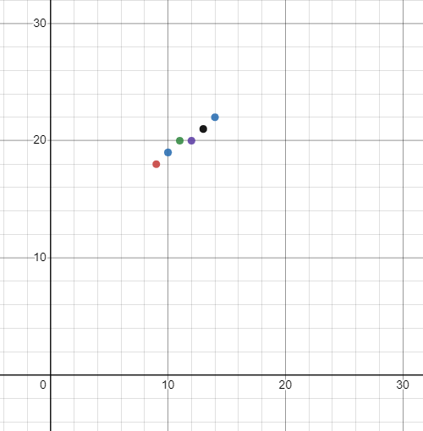

**3. Advantages of Simple Bresenham Line Drawing Algorithm:** The algorithm helps create a line using pixels with ease and creates fixed points in order to draw the line. Otherwise, this would be hard to implement by hand which helps a lot with a bit of accuracy. It is also fast to make and more accurate than the DDA method.

**4. Disadvantages of Simple Bresenham Line Drawing Algorithm:** The algorithm has disadvantages in that it can only draw lines with a slope between 0 and 1, using integers that restrict anti-aliasing to the line. The algorithm is for the basic line drawing and without anti-aliasing creates jagged lines.

**5. REFLECTION 🙂**

This hand in for the most part was straightforward but did require a bit of clarification because of small mistakes. Mistakes such as accidentally finding the points after the ending coordinate (whoops) and not understanding what the current point meant (x_k, y_k). I fixed these problems by literally just looking at the solution which was pretty far off and so I just implemented “trial and error” and we are good. I received help from Paul which helped me understand what the values mean and what needed to be done during the arithmetic. If I did this again I would not spend so much time figuring out what the values mean and instead just do it right away. The moral of the story is not to overthink things because the actual solution may be a lot easier than you think.

**Field of Computer Science (Exit Assessment Part)**

Computer animation specialists are professionals who create a range of mediums, including films, television shows, video games, mobile apps, and websites. They often work as part of a team and may be involved in every stage of the animation process, from developing initial concepts to final rendering. In order to do their job effectively, they need a variety of skills, including 3D rendering, visual effects, game art and design, and proficiency with computer generation programs.

One of the key techniques that computer animation specialists use is rendering, which allows them to create multiple effects and make images and other forums look more polished and professional. They may use software using algorithms like the Bresenham line drawing algorithm or the DDA algorithm to create smooth, realistic lines and curves in their designs. These algorithms make it easier to create simple lines and curves and also allow for anti-aliasing, which creates the illusion of a perfect line or curve.

These techniques are vital to the efficiency and effectiveness of the occupation. Without them, everything that computer animation specialists do would have to be done manually, pixel by pixel. The use of algorithms and other techniques allows them to create high-quality animations in a more efficient and cost-effective way.

**References**

<https://www.itcareerfinder.com/it-careers/computer-animator.html#:~:text=Computer%20animators%20create%203D%20motion,games%2C%20mobile%20apps%20and%20websites.>

<https://www.indeed.com/career-advice/resumes-cover-letters/animation-skills>

[**https://www.gatevidyalay.com/tag/disadvantages-of-bresenham-algorithm/**](https://www.gatevidyalay.com/tag/disadvantages-of-bresenham-algorithm/)